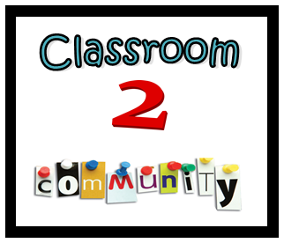

**Please select your preferred time for sessions (multiple sessions may be chosen:**

|  |  |
| --- | --- |
| Fridays 8:30 – 9:30am |  |
| Fridays 1:30 – 2:30pm |  |
| Wednesdays 6:30 – 7:30pm |  |

**Please indicate your response to last year’s topics:**

|  |  |  |
| --- | --- | --- |
| **Topic** | **Interested in Attending** | **Comment** |
| How to support your child's learning at home |  |  |
| Numero |  |  |
| Let's Get Literate |  |  |
| School Banking |  |  |
| Maths Games for Early Years |  |  |
| Road Safety |  |  |
| Why is Physical Activity Important? |  |  |
| Protective Behaviours |  |  |
| High School Transition |  |  |

In 2017 BPPS launched the Classroom2Community project. This project aims to build stronger community connections by providing a variety of information sessions for school families about school programmes as well as how to help your child at home.

For 2018, we’d like to ask for parent feedback and input regarding information sessions for this year. Please complete this survey and return it to the front office by Thursday 8th March to go in the draw for a gift pack valued at $20.

**Please indicate your response to proposed topics for 2018:**

|  |  |  |
| --- | --- | --- |
| **Topic** | **Interested in Attending** | **Comment** |
| What Does Science Look Like At BPPS? |  |  |
| Maths Games For Upper Primary |  |  |
| How To Read To Your Child At Home (K-2) |  |  |
| Talk4Writing |  |  |
| Basic First Aid |  |  |

**Do you have any suggestions for topics you’d like covered?**

|  |  |
| --- | --- |
| **Topic** | **Comment** |
|  |  |
|  |  |
|  |  |
|  |  |
|  |  |

**Do you have any other ideas for how we could continue to improve our Classroom2Community connections?**

**Family Name LA**

Thank you so much for your time, it’s greatly appreciated.